**Advance Excel Assignment 2**

1. **What does the dollar ($) sign do?**

* When you copy some formulas, these cell references can adjust automatically, this is called as relative reference where references are adjust based on the cell in which it is applied. In case, if you don’t want to adjust the reference. We use the Dollar sign locks the column or row proceeding it.
* A dollar symbol, when added in front of the row and column number, makes it absolute (i.e., stops the row and column number from changing when copied to other cells).
* The keyboard shortcut is F4.
* Simply place the cursor on the cell reference where you want to add the dollar sign and press is once. You will notice that it will change the reference by adding/removing the $ sign (based on what’s the original reference).

1. **How to Change the Reference from Relative to Absolute (or Mixed)?**

There are 3 types of references:

* Relative reference: you don’t use a dollar ($) sign in the references at all.
* Absolute reference: you use the dollar sign in twice in a reference (such as $C$3).
* Mixed reference: you use the dollar sign ($) only once (such as $C3 or C$3)

To change the type of cell reference:

* Select the cell which contains formula.
* In the formula bar, select the reference that you want to change.
* Press F4 to switch between the reference types.

=$D4*F$2: In this case column D is fixed and row 2 is fixed.

|  |  |  |  |  |  |  |
| --- | --- | --- | --- | --- | --- | --- |
|  |  |  |  | Commission | | |
|  |  |  |  | 10% | 15% | 20% |
| **Item** | **Price** | **Quantity** | **Total** | **Tier1** | **Tier2** | **Tier3** |
| A | 15 | 15 | 225 | 22.5 | 33.75 | 45 |
| B | 20 | 20 | 400 | 40 | 60 | 80 |
| C | 12 | 18 | 216 | 21.6 | 32.4 | 43.2 |
| D | 18 | 8 | 144 | 14.4 | 21.6 | 28.8 |
| E | 8 | 10 | 80 | 8 | 12 | 16 |
| F | 10 | 20 | 200 | 20 | 30 | 40 |
| G | 20 | 10 | 200 | 20 | 30 | 40 |

1. **Explain the order of operations in excel?**

When we are evaluating, excel follows a standard math protocol called ‘order of operations. In general, excels order of operation follows the **PEMDAS**.

First, any expressions in parentheses are evaluated. Parentheses essentially override the normal order of operations to ensure certain operations are performed first.

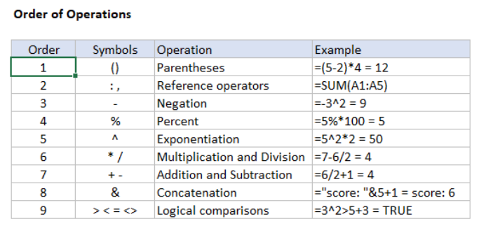

1. **What, according to you, are the top 5 functions in excel and write a basic syntax for any of two?**
2. **SUM:** This is most basic and commonly used formula. It simply adds up the numbers within the range of cells.

Syntax: =SUM (A1:A5).

1. **AVERAGE:** As the name suggests, this formula returns the average of a range of cells.

Syntax: =AVERAGE (A1:A10).

1. **IF:** This is a very powerful and commonly used formula. It basically allows you to test a condition, and then return one value if the condition is met, and another value if it isn’t.

Syntax: =IF(A1>10, “Yes”)

if the value in cell A1 is greater than 10. If it is, the formula will return the word “Yes”, if not, it will return the word “No”.

1. **MIN:** This formula returns the smallest value in a range of cells. So, if you had cells A1 to A10 containing numbers, you could find the smallest number with the formula.

Syntax: =MIN (A1:A10).

1. **MAX:** This formula returns the largest value in a range of cells. So, if you had cells A1 to A10 containing numbers, you could find the largest number with the formula.

Syntax: =MAX (A1:A10).

1. **When would you use the subtotal function?**

Subtotal Function in Excel is a wonderful formula that can be used to perform some specific arithmetic and logical operation on a defined range of cells.

Microsoft Excel defines Subtotal Function as “It returns a subtotal in a list or database”.

Subtotal formula takes two arguments:  
1. Operation Code  
2. Range of Cells.

=subtotal (Operation Code, Range1)

=SUBTOTAL (9, B2:B11)

Here ‘Operation Code’ specifies the type of mathematical operation that you like to perform on the specified range of cells.

|  |  |  |
| --- | --- | --- |
| **Operation Code** | **Operation Name** | **Description** |
| 1 | AVERAGE | Calculates the Average of specified range. |
| 2 | COUNT | Counts the number of cells in a specified range. |
| 3 | COUNTA | Counts the number of non-empty cells in a specified range. |
| 4 | MAX | Finds the Largest Value in the specified range. |
| 5 | MIN | Finds the Smallest Value in the specified range. |
| 6 | PRODUCT | Calculates the product of cells in specified range. |
| 7 | STDEV | Estimates Standard Deviation in the specified range. |
| 8 | STDEVP | Calculates Standard Deviation based on the entire population. |
| 9 | SUM | Calculates the Sum of specified range. |
| 10 | VAR | Estimates variance in the specified range. |
| 11 | VARP | Estimates variance based on the entire population. |

Subtotal gives you two important capabilities over traditional functions.

* Feature that ignores hidden rows.
* It can produce results dynamically.

1. **What is the syntax of the VLOOKUP function? Explain the terms in it?**

[**VLOOKUP**](https://excelexposure.com/excel-video-lesson-advanced-vlookup-examples/)**:**This is another very powerful and commonly used formula. It allows you to look up a value in one table, and then return a corresponding value from another table.

Syntax: =VLOOKUP (H5; A2:F11; 3; FALSE).

=VLOOKUP (lookup value, table array, col_index_num, [range lookup]).

VLOOKUP makes it effortless to look for an exact match from the table. Let’s take a look at how to do this with the help of an example:

* In the example below, we are using the VLOOKUP function to find the value of the exact match of ID from the given table. So, we set the first parameter as the lookup value, which is the cell H5.

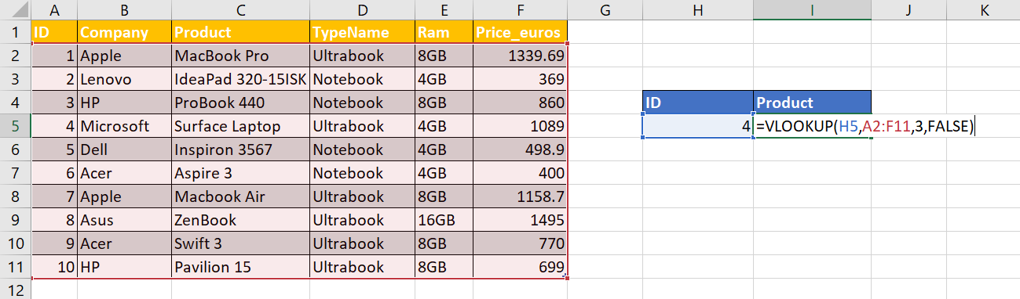

* We specify the location of the table in the second argument. As you can see, the table location is A2:F11.
* The third argument specifies the Column Index number. This tells us what value should be returned from the row that we are looking up for. In the example, the product column is 3.
* The last argument is a Boolean Expression. Here, the value is set to FALSE for the VLOOKUP function to return an exact match for the value. An N/A error is displayed in case the exact value is not found.